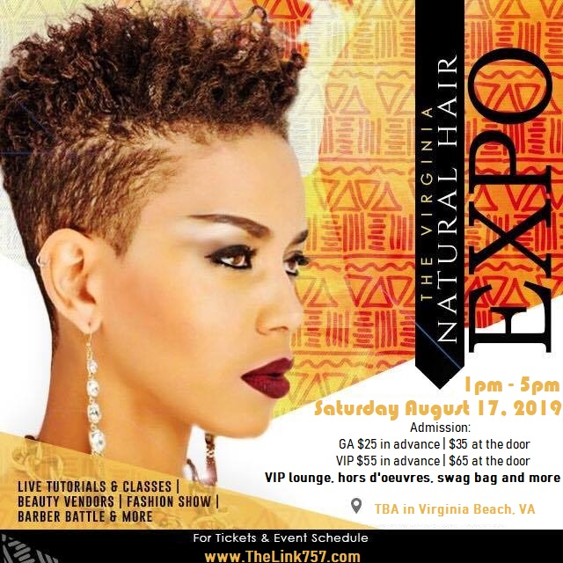

We hope you save the date and consider partnering with us for our sold out event on Saturday, August 17, 2019, in Virginia Beach, VA. The Virginia Natural Hair Expo is an annual one day event. The purpose of the event is to educate those in the natural community on the importance of proper care of their natural tresses. The event will also feature Nail & Body care, hair care classes and live tutorials, as well as Barber Battles, salon competitions, and more! The Virginia Natural Hair Expo was designed to share information, techniques, inspiration and products to aid individuals in their natural hair journey. This is also an event where you can network and meet those with like interest! We are expecting over 300+ patrons from All walks of life, who share a common interest in Healthy Living.

We are giving Sponsors an opportunity to showcase their product/service. The cost to participate as a vendor is $75.00. However, We have sponsorship opportunities available to those who would like to partner and build more awareness of their brand! We invite you to take advantage of this unique opportunity to grow your business by completing the attached sponsorship agreement.

**Sincerely,**

**Shawnta Brown (CEO, Link, The)**

**Thelink757@gmail.com**

**VaNaturalHairExpo.com**

**HIGHLIGHTS OF #VNHE**

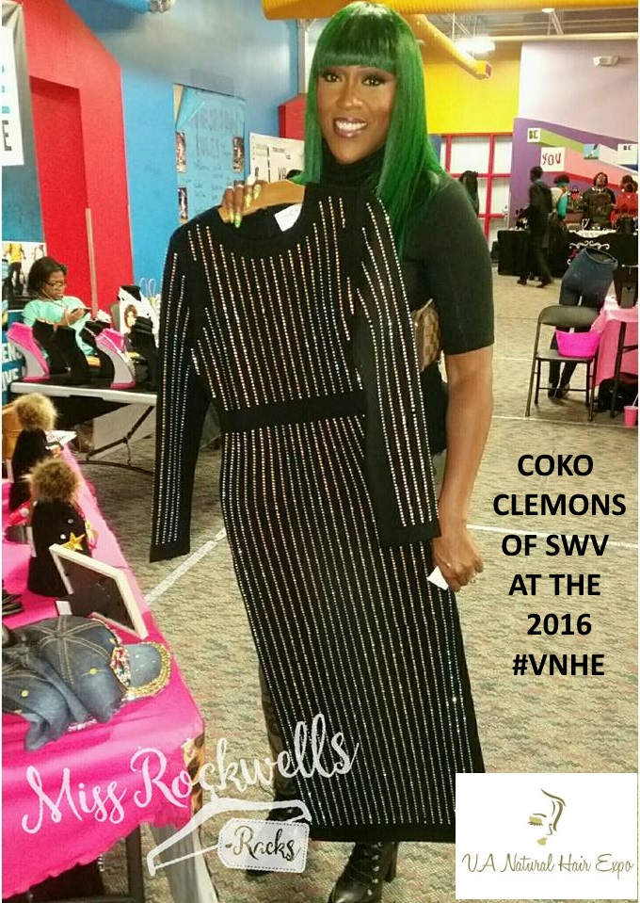

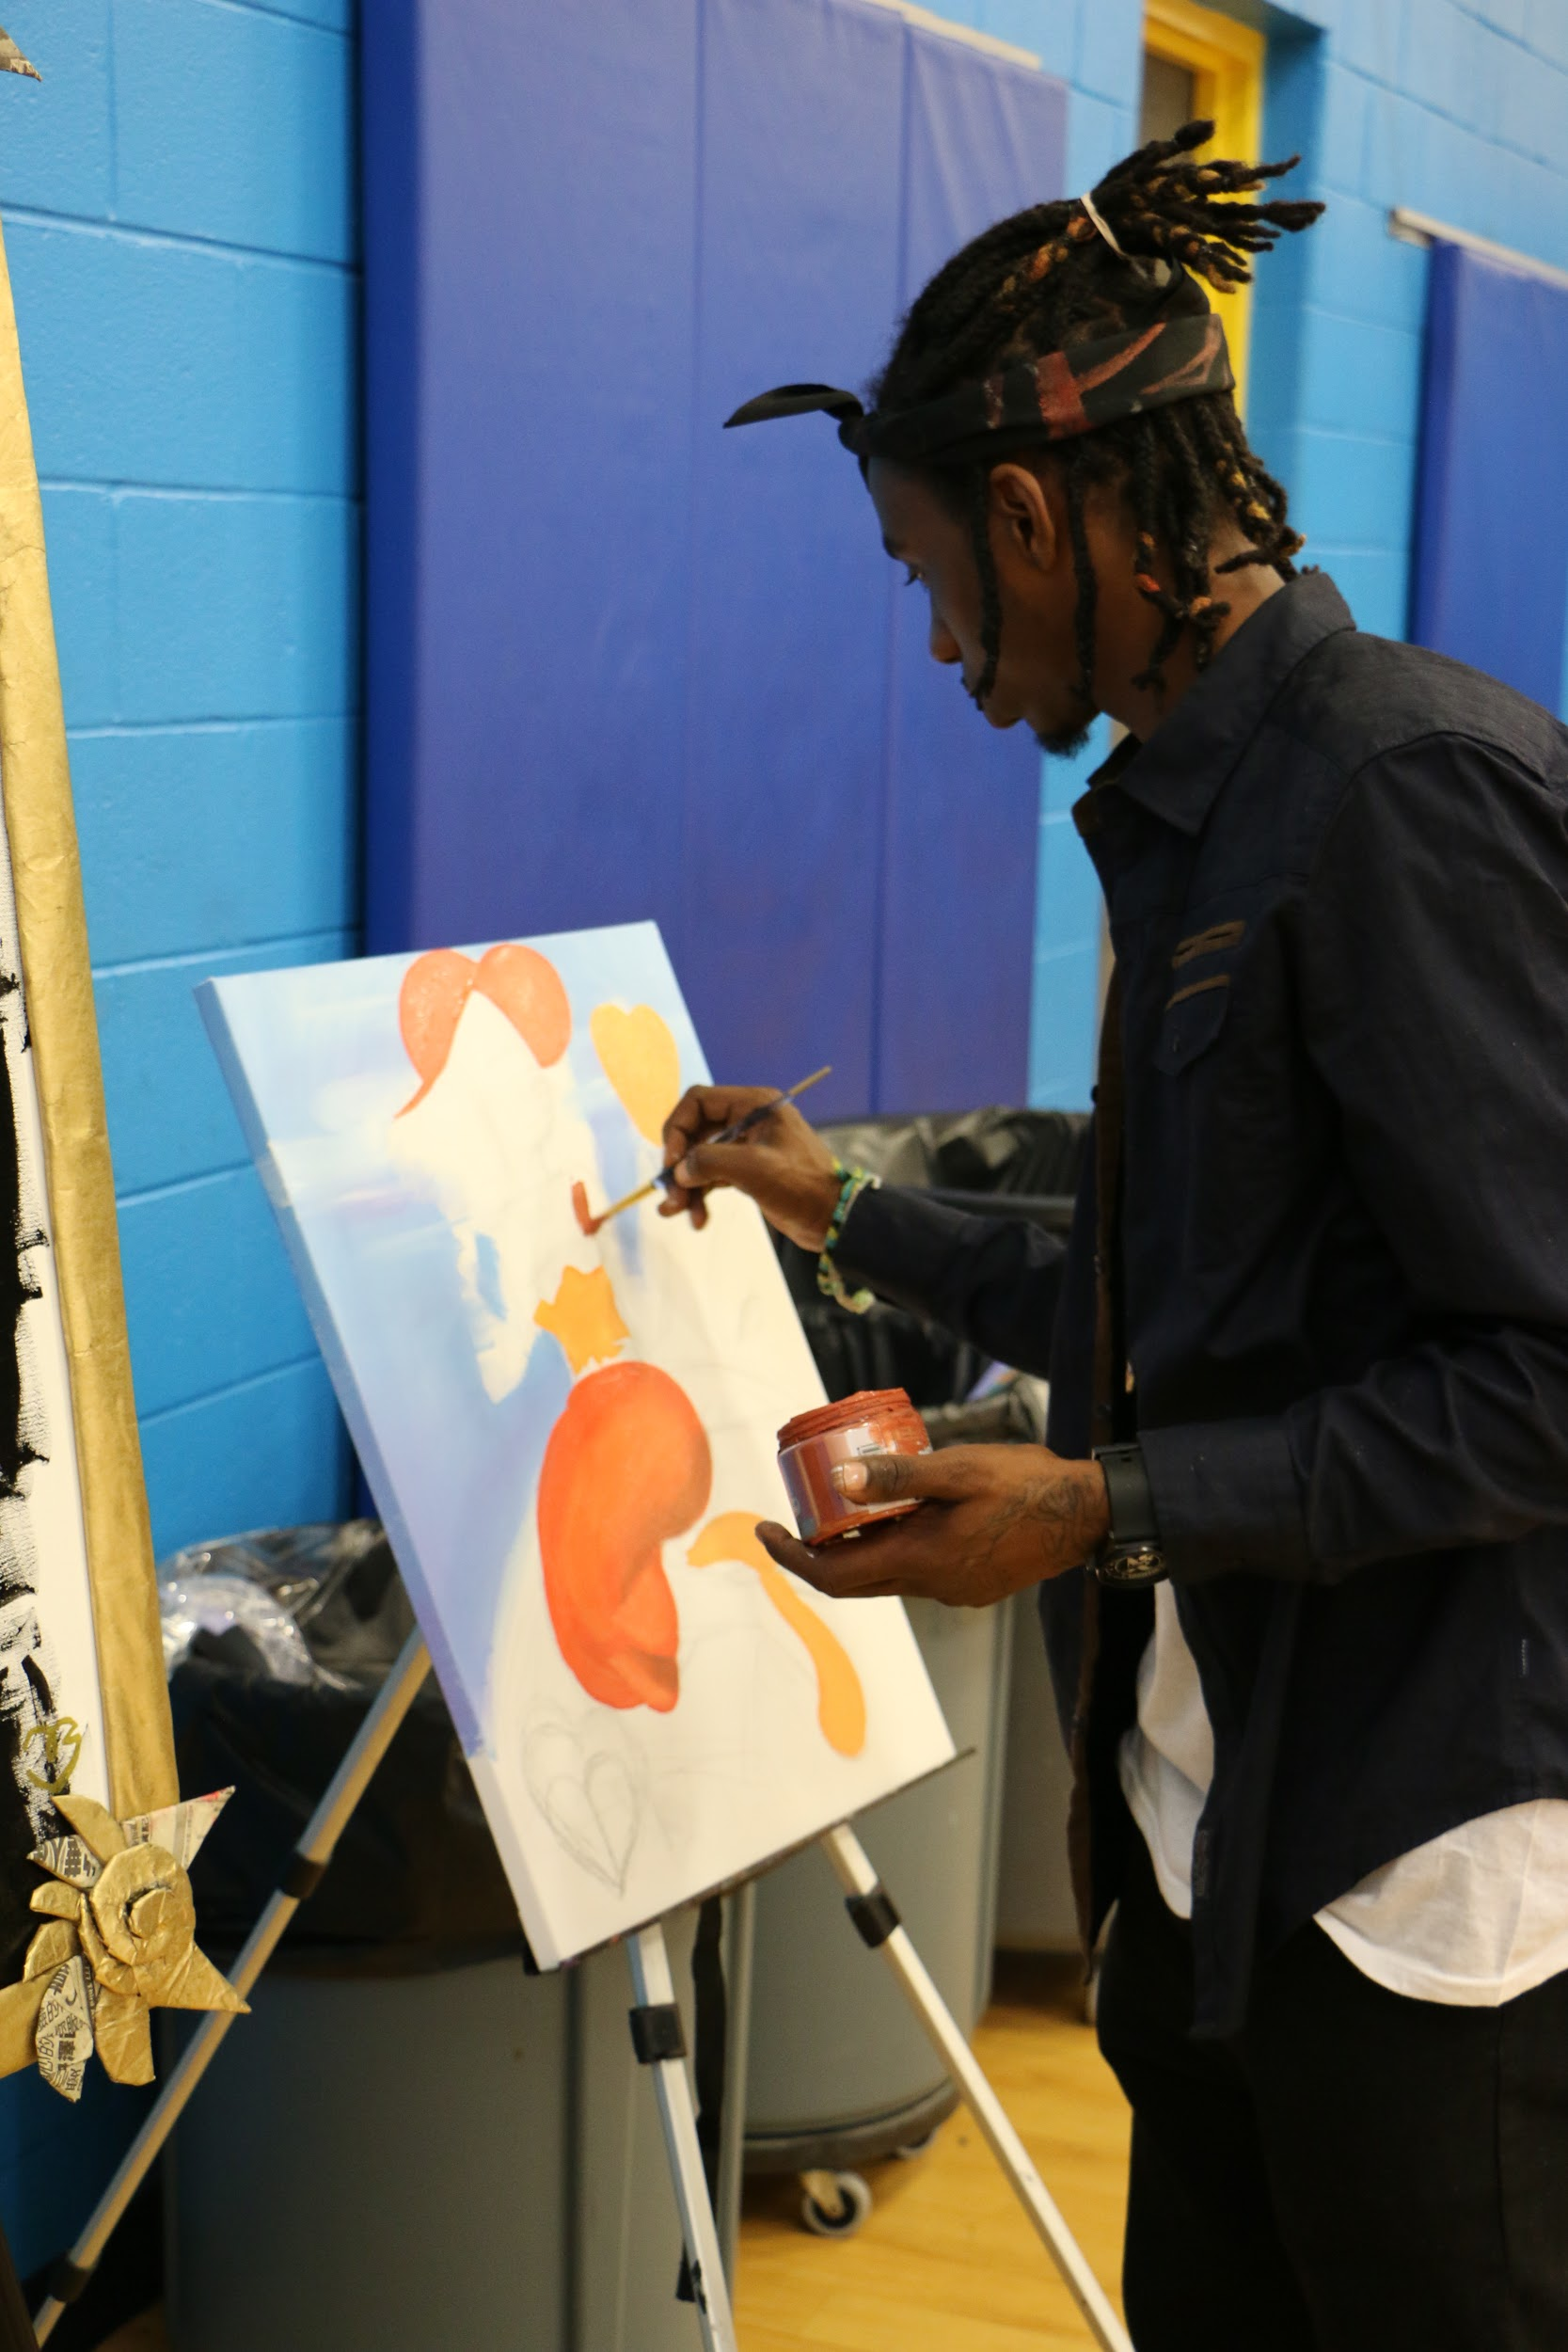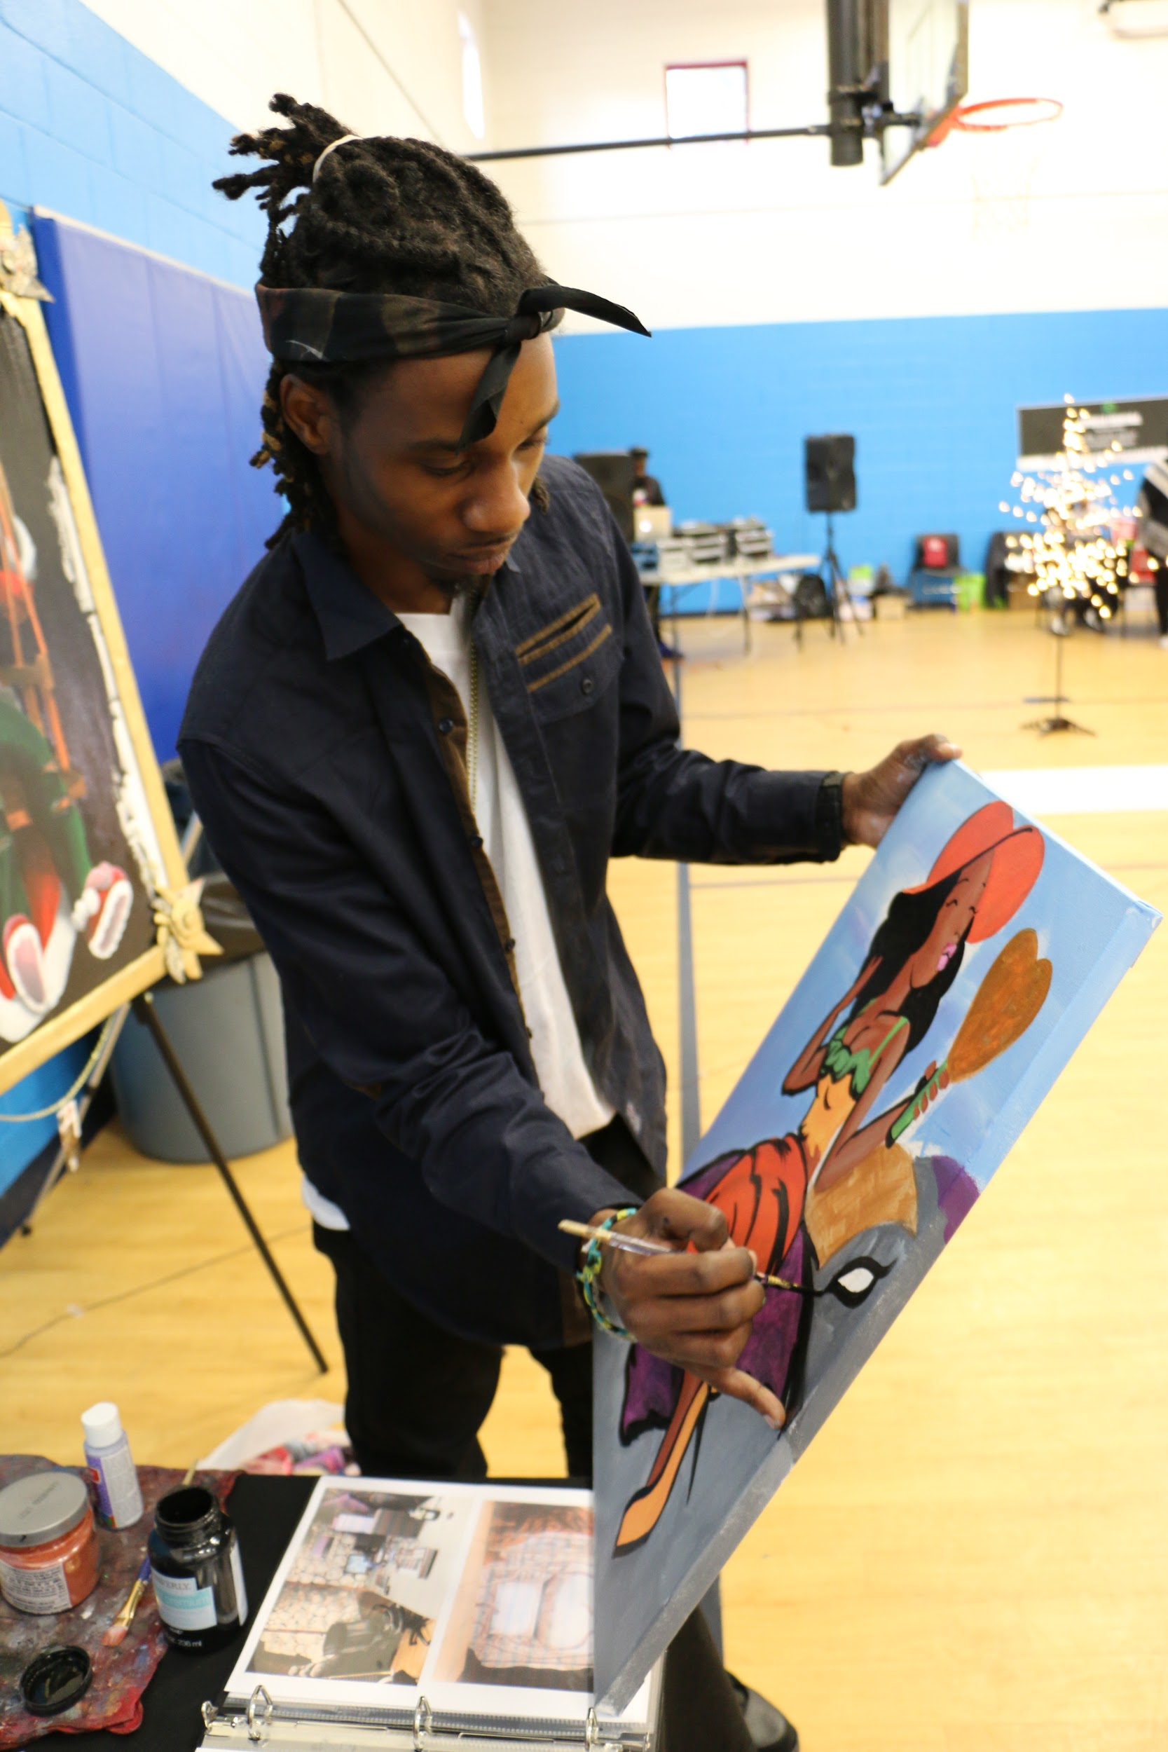

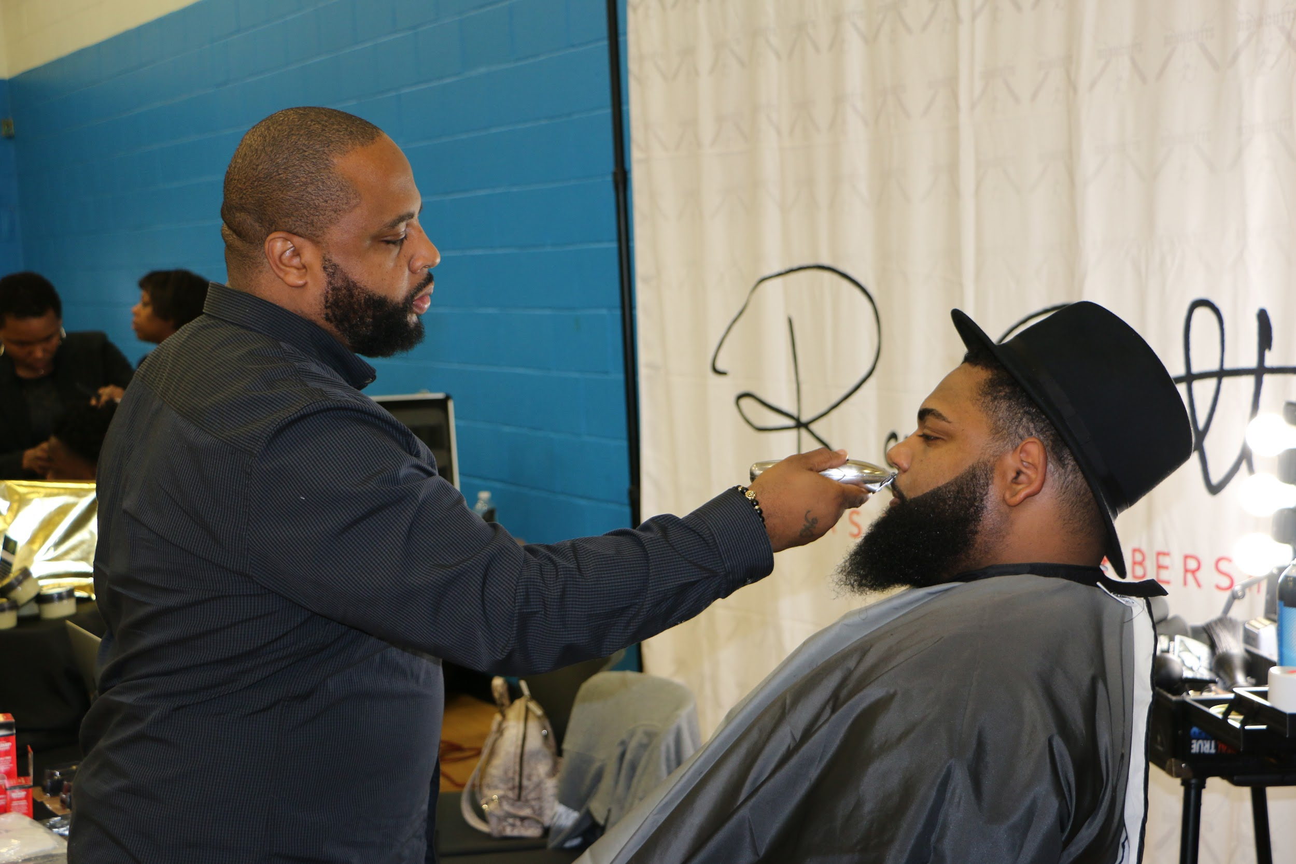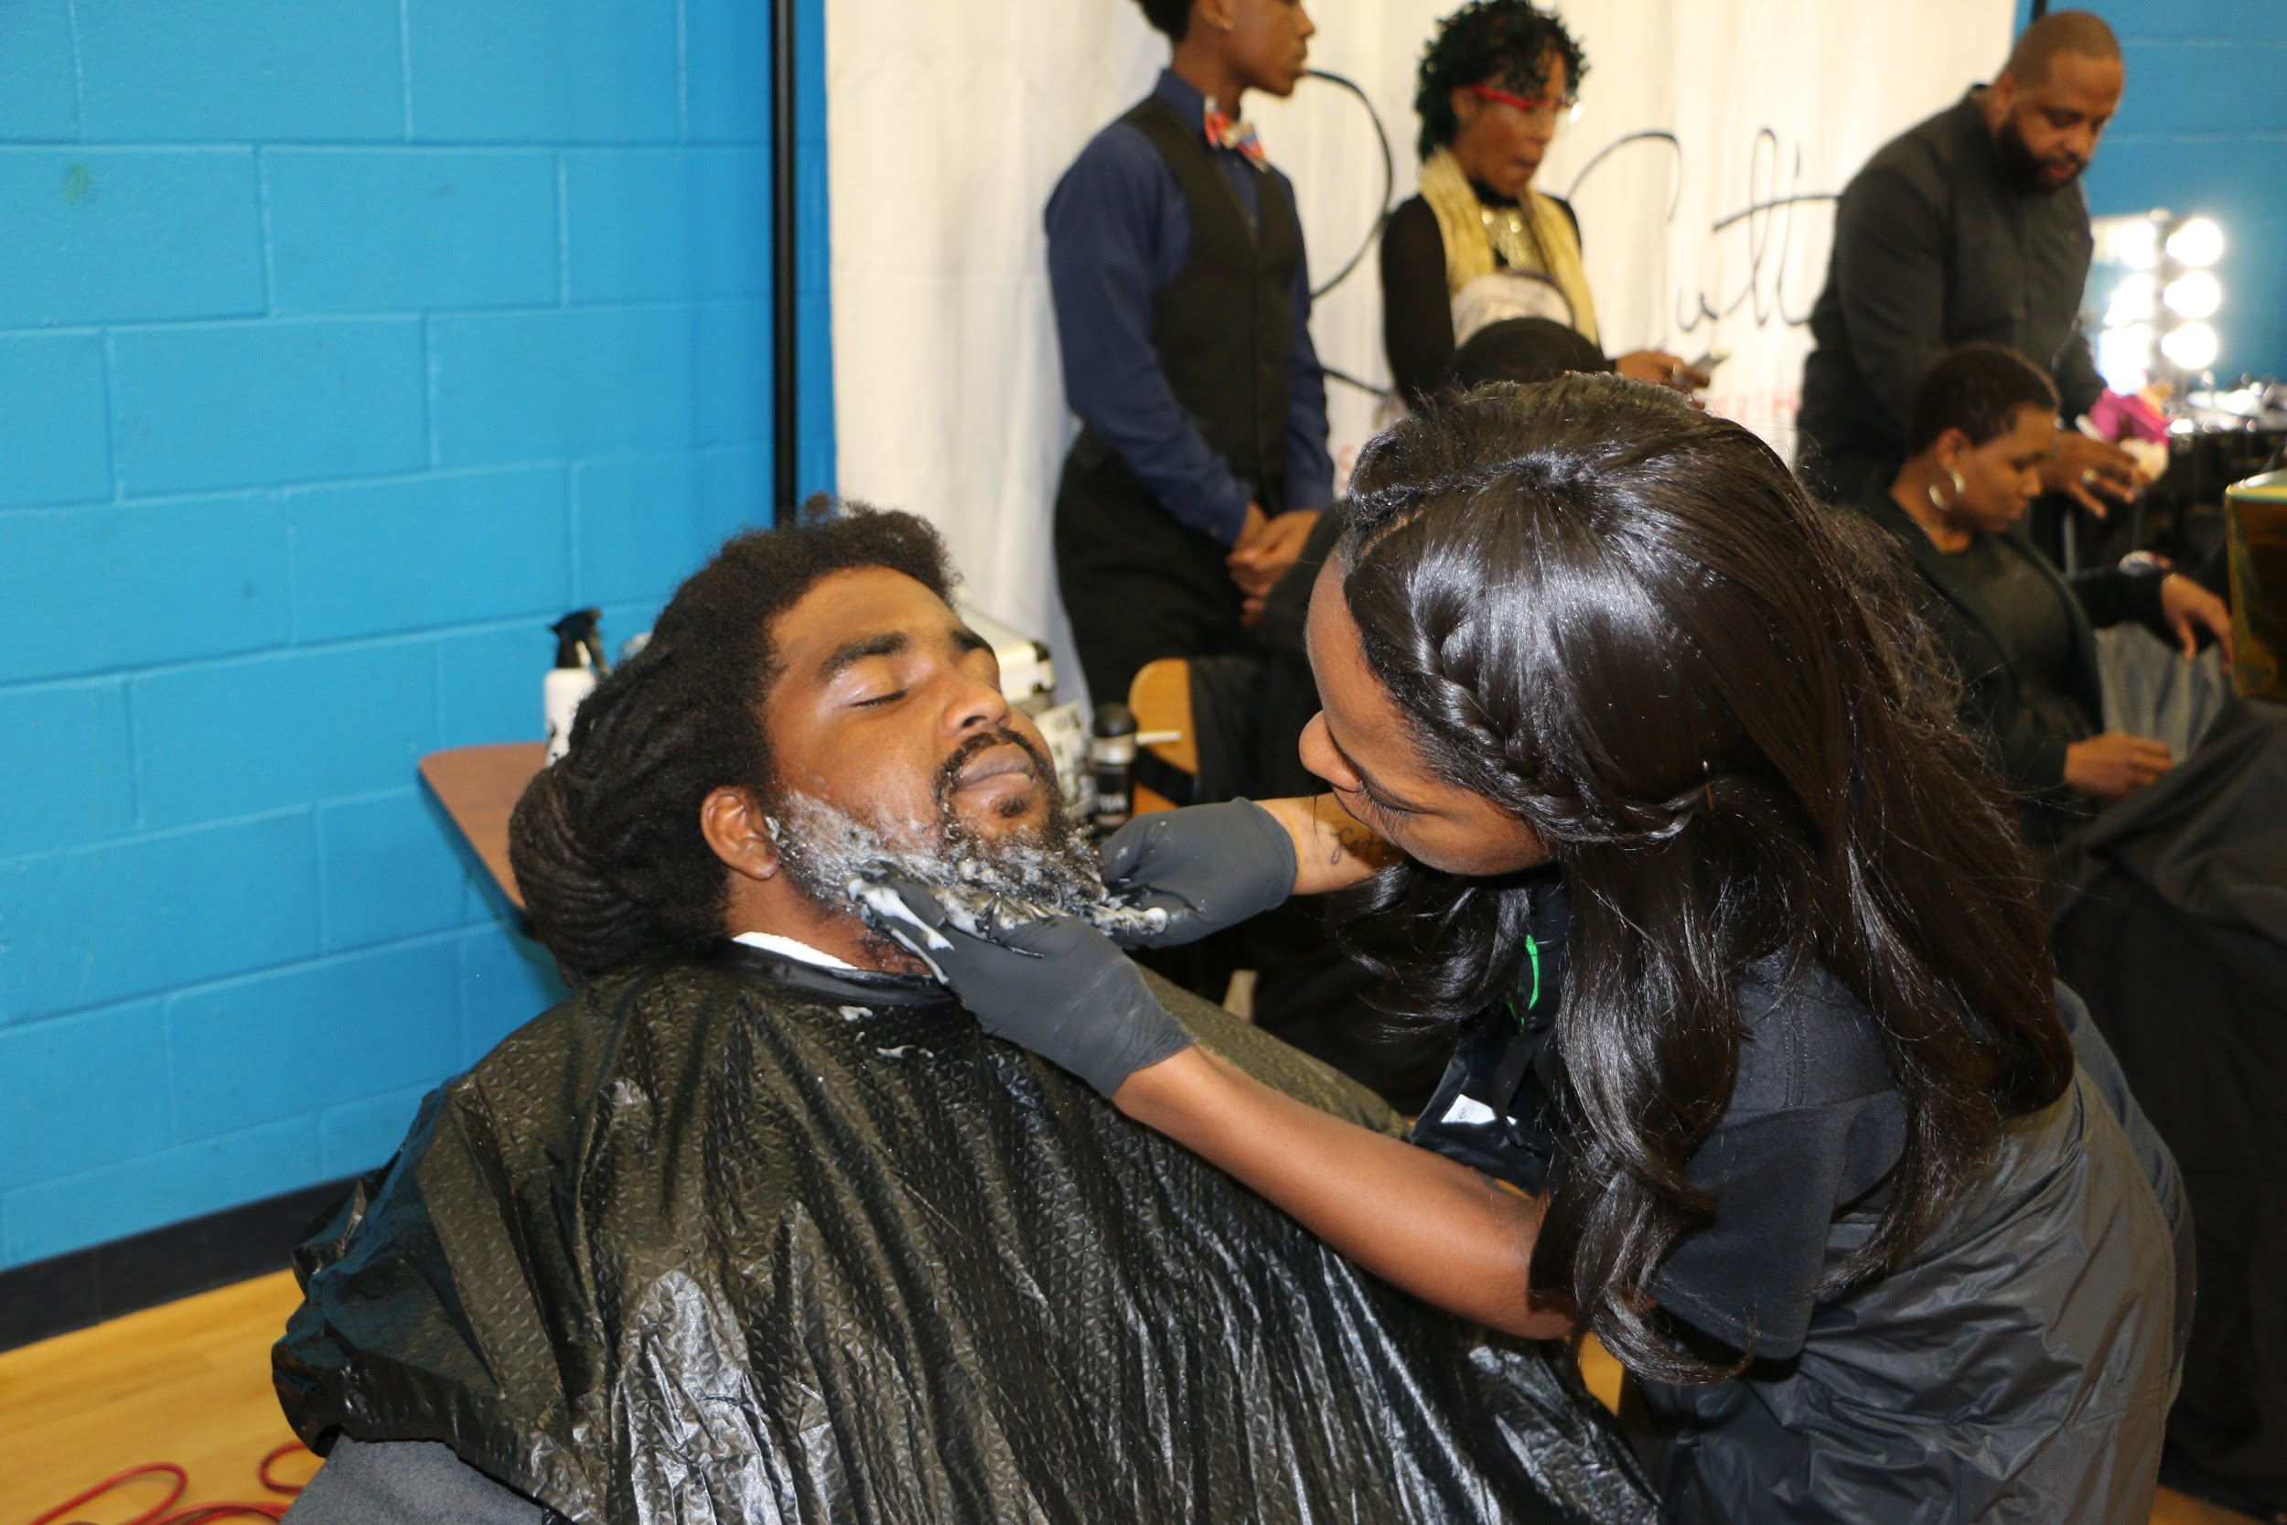

***Sponsorship Opportunities***

***Platinum Sponsor Package: $600.00 (Only 1 available)***

● 2 Complimentary vendor table at the expo with choice/prime positioning (1pm – 5pm)

● 4 Wristbands for guests to attend the expo additional tickets can be purchased.

● Complimentary 30 minute slot for class or demonstration from your company at the expo. May be broken into 10-15 minute segments or used as a 30 minute class.

● Organizations name and or logo printed on literature and mentioned in any press including radio.

● Advertisement as the Platinum Sponsor of the Expo.

● Company acknowledgement on website as the HOST of this expo with a web link to your personal site.

● Organization Banner over main event area and around your large booth space.

● signs may be placed in hallways as well. (Signage/Décor Provided by you)

● Maximum exposure as the presenter of the 3rd Annual Virginia Natural Hair Expo.

***Gold Sponsor Package: $300.00 (Only 2 available)***

● 1 Complimentary Vendor table at expo (1pm-5pm).

● 2 wristbands for guests to attend the expo.

● Complimentary 20 min. slot for class or demonstration from your company at the expo. (1pm.- 5p.m.)

● Company logo acknowledgement on website with a web link and organizations name

mentioned at the event and on marketing and printed literature.

● Banner or marketing poster (provided by you) hung at the expo

***Silver Sponsor Package: $200.00***

● Complimentary vendor table at expo (1pm - 5pm).

● 1 Wristbands for guest to attend the expo.

● Organizations name mentioned during event, listed on website and all marketing

Materials.

***Bronze level donations will also be accepted in the form of:***

● Gift sets or large items for giveaways/ door prizes.

● 100 Full Size Products for our VIP swag bags

● Samples and literature to go inside the swag bags (100 sample min. please). We will do swag bags for the first 100 attendees.

● Gift card/Gift certificates for use on your website.

● Donations of any brand new Natural Hair products, accessories or beauty items.

● Monetary donations can be made as well.

2019 Virginia Natural Hair Expo Sponsorship Proposal

Contact Person _______________________________________________________________

Company Name ______________________________________________________________ Address__________________________________________________________

City _______________ State_____ Zip Code___________

Website _______________________________________________________________________

Phone ( _________ ) ________________________ Mobile ( _________ ) _________________

Email ________________________________________________

Products or Services to be showcased or on sale during the event: __________________________________________________________________________

TERMS AND CONDITIONS OF EXHIBITING

1. EXHIBITORS MUST ARRIVE NO LATER THAN 11:30am AND BE FULLY SET UP BY 12:45pm. (DOORS OPEN AT 11:00AM FOR SETUP; OPENS TO PUBLIC AT 1:00 pm)

2. EXHIBITORS MUST HAVE COMPLETELY VACATED THE PREMISES BY CLOSE OF DAY, 6pm.

3. EXHIBITS MUST BE STAFFED AT ALL TIMES DURING THE EVENT HOURS. EVENT COORDINATORS ARE NOT RESPONSIBLE FOR LOST OR STOLEN GOODS.

4. EXHIBITOR WILL BE PROVIDED ONE (1) TABLE AND ONE (1) CHAIRS

5. DISPLAYS AT THE FRONT OF THE STALL MUST NOT INTERFERE WITH THE VISIBILITY OF ADJOINING EXHIBITORS. DISPLAYS MAY NOT EXTEND BEYOND THE CONFINES OF EXHIBIT SPACE.

6. EXHIBITORS MAY PLACE BROCHURES & OTHER PROMOTIONAL LITERATURE ONLY IN THEIR SPACE AND NOT IN ANY OTHER PART OR THE FACILITY. (Unless already discussed and approved)

7. EXHIBITORS MUST REMOVE ALL THEIR BOXES AND PAPER FROM EXHIBIT AREA AT THE CLOSE OF DAY.

8. THERE WILL BE NO REFUNDS OF ANY KIND.

9. EXHIBITORS MUST ABIDE WITH HEALTH AND SAFETY REGULATIONS WHILE ON PREMISES. ALL ENTRANCES, EXITS AND PATHS MUST BE KEPT CLEAR AND FREE OF OBSTRUCTIONS.

10. ALL MATERIALS USED IN THE EXHIBIT AREA MUST BE FLAMEPROOF AND FIRE RESISTANT IN COMPLIANCE WITH LOCAL FIRE ORDINANCES AND FIRE REGULATIONS OF EXHIBITION FACILITY.

11. ALL BOOKINGS FOR EXHIBIT BOOTHS MUST BE IN WRITING WITH ACCOMPANYING SIGNATURE AND PAYMENT.

12. VIRGINIA NATURAL HAIR EXPO. THE LINK757, OR IT’S AFFILIATES HAVE NO LIABILITY FOR THE SAFETY OR SECURITY OF ANY LOSS, DAMAGE OR DESTRUCTION OF PROPERTY.

13. VIRGINIA NATURAL HAIR EXPO, THE LINK757 AND THE EVENT MANAGEMENT WILL BE THE FINAL AUTHORITY.

RETURN THIS FORM TO: VaNaturalHairExpo@gmail.com

SEND PAYMENT THRU PAYPAL OR CASHAPP TO: [SHAWNTABROWN@ROCKETMAIL.COM](mailto:SHAWNTABROWN@ROCKETMAIL.COM) | $TheLink757 OR WE CAN MAKE OTHER ARRANGEMENTS FOR PAYMENT!

I have read and understand the terms and conditions listed above and agree to abide by them:

_____________________________________/__________________/____________________

Signature Date Company Name